Board of Directors List README

Ed Caruso

Sept 1,2014

This document is will explain how to add to the data files when you have the need to add new information to the Board of Directors List webpage for the Laurel Little Theater website (<http://www.laurellittletheatre.com/boards.php5>)

In the directory where the site is stored you will see a directory and a file

1. Directory: boards
2. File: boards.php5

(Some web hosting companies want a file ending in .php and some want .php5. We have both and they are identical. Currently we use boards.php5)

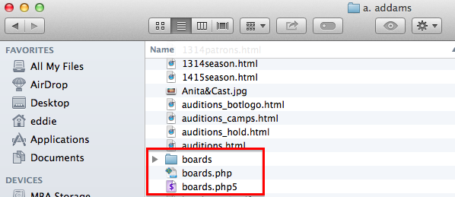

Inside the boards directory you will fine the data files used by the boards.php5 script to construct the cast list web page(s) as seen on the site.



The nice thing about using a script like boards.php5, is that even though we have over 50 different board of director lists, we use one program to construct and display any individual board of directors. PLUS..in this case there is no pulldown.data file such as the one used by the casts.php5. Because the information for the pulldown menu can be completely derived from the list of files in the boards directory, there is not need to have a separate file to construct the pulldown menu … I will delve into that more later. Suffice to say the only thing you need to add a new board of directors, is a new data file of names and titles that is properly formatted that the boards.php5 file can process.

So, looking in the boards directory you will find one file for each season’s board of directors. Take See the next page.

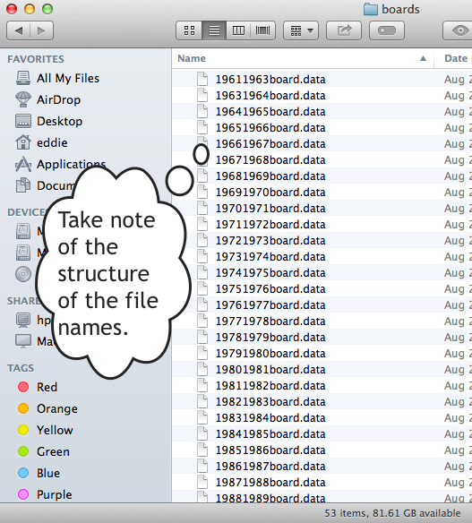

First, the boards.php5 script looks in the boards directory, sorts the list of files in reverse order so that the most recent year, is listed first. With the list of filenames in memory, the information used to construct the pulldown menu. The nice thing about this is that the pulldown menu is dynamic and self-adjusting. You add a new data file for a new season’s board of directors, the pulldown menu will automatically be adjusted to include it AND in the correct place in the menu. One additional thing to understand is t hat the MOST RECENT season is automatically marked as CURRENT SEASON in the pulldown menu.

Collectively the nice thing is we don’t need 50+ html documents to manage for the display of all the board of directors pages.. it’s one script and several data files. If something needs to change in the display, it’s one script to modify… to add a new season, it’s one data file. This greatly reduces maintenance work by the support staff.(working in the boards directory.

Contents of boards directory

1. One file for each season’s board of directors.

The pattern for the file name is important. When adding a new data file, you must match the existing

pattern <yyyyxxxx>board.data. Where yyyy is the year the season begins, and xxxx is the year the season

ends. Such as 20142015board.data

Next, The important thing Is to understand the internal structure of the file.

To demonstrate the data file structure I have chosen, the file for the 2002-2003 season

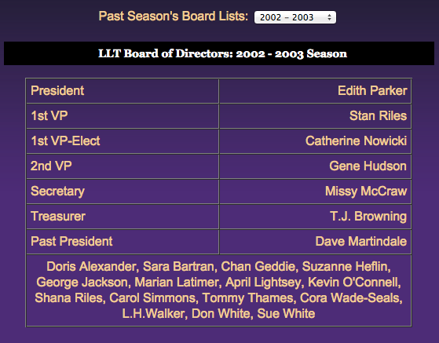

Note most rows are 2 columns and some rows of the table are one column… you will see how that is done below.

President|Edith Parker

1st VP|Stan Riles

1st VP-Elect|Catherine Nowicki

2nd VP|Gene Hudson

Secretary|Missy McCraw

Treasurer|T.J. Browning

Past President|Dave Martindale

Doris Alexander, Sara Bartran, Chan Geddie, Suzanne Heflin,<br />George Jackson, Marian Latimer, April Lightsey, Kevin O'Connell,<br />Shana Riles, Carol Simmons, Tommy Thames, Cora Wade-Seals,<br />L.H.Walker, Don White, Sue White

In the data file you will see a vertical bar character (|)..also called a pipe character. This character indicates a separation data into two columns. The left column (Title on the Board) will be left justified and the second column (Name of Person) will be right justified. No vertical bar in the data results in the data being in one cell spanning two columns. The script is not designed to handle more than 2 columns per line at this time. Please note this from the example above ….

Doris Alexander, Sara Bartran, Chan Geddie, Suzanne Heflin,<br />George Jackson, Marian Latimer, April Lightsey, Kevin O'Connell,<br />Shana Riles, Carol Simmons, Tommy Thames, Cora Wade-Seals,<br />L.H.Walker, Don White, Sue White

Is actually ONE LONG LINE in the data file. That word wrap was unavoidable in the documentation. Second thing to notice is that there are HTML line break tags in the data (<br />). This is so that the lines will break when we want, no name is split on two lines.

There is one more thing to know. The only way to know this next fact would be to read this document or read the php code.

IF THE FIRST TWO CHARACTERS in the line of information from the data file is two asterisks (\*\*), the remainder of the information is handled as RAW HTML. No processing takes place and the HTML is passed directly into the document. This was added to give support staff more flexibility.